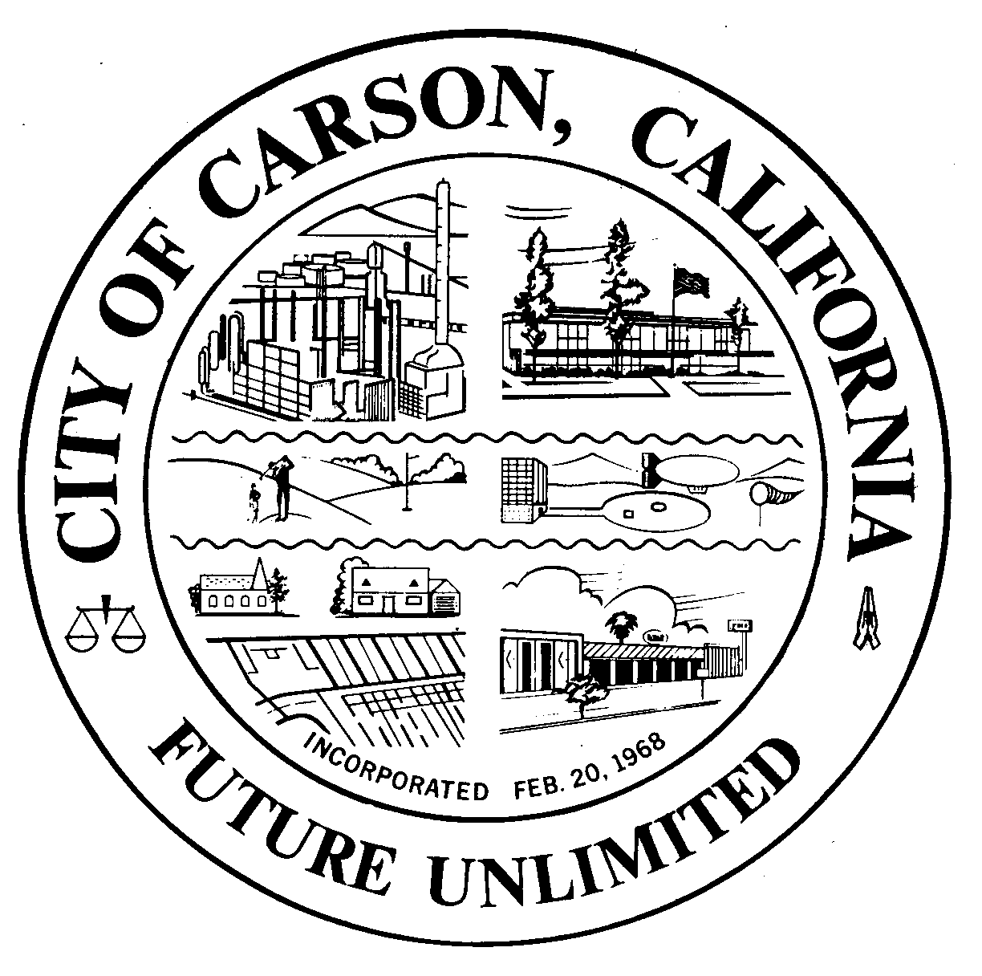
A G E N D A
CITY OF CARSON
REGULAR MEETING OF THE ENVIRONMENTAL COMMISSION
701 East Carson Street, Carson, CA 90745
EXECUTIVE CONFERENCE ROOM, 2ND FLOOR
Monday, January 6, 2014
6:30 p.m.

- CALL TO ORDER:

- PLEDGE OF ALLEGIANCE:

- ROLL CALL: Environmental Commissioners:
Burr, Hellerud, Hopson, Jimenez, Love, Mack, Muckey, Perry, Taylor
- AGENDA POSTING CERTIFICATION: In accordance with the Americans with
Disabilities Act of 1990, if you require a disability related modification or accommodation to attend or participate in this meeting, including auxiliary aids or services, please call the City Clerk’s office at 310-952-1720 at least 48 hours prior to the meeting. (Government Code Section 54954.2)
- AGENDA APPROVAL:
- ORAL COMMUNICATIONS: For items NOT on the agenda. Speakers are limited to three minutes.
- MINUTES APPROVAL:
  - November 6, 2013
  - December 4, 2013
- UNFINISHED BUSINESS
a. Carson Revolving Energy Fund
b. Carson Energy Action Plan
- NEW BUSINESS
  - Southern California Edison Presentation
  - Enhanced Electrical Safety Policy, HERO
- WRITTEN COMMUNICATIONS
  - None
__________________________________________________________________________
- ORAL COMMUNICATIONS
  - Audience
  - Commissioners
  - Staff
    - Oxy Tour (January 18th or January 25th)
    - Oxy and Shell EIR Joint Planning Commission and Workshop (Tentative date, February 11)
    - HOA Presentation Project
    - Possible February West Basin Presentation
    - Logo Discussions
__________________________________________________________________________
- ADJOURNMENT
Upcoming Meetings: February 5, March 5, April 2, May 7

